Cloud Security Architecture Review
MediCare Plus Clinic — Azure Environment
Unit: COIT13236
Student Name: Kishan Patel
Student ID: 12232740

Introduction

The design, setup, and security measures of Medicare Plus Clinic's Microsoft Azure environment are assessed by the Cloud Security Architecture Review. The clinic uses a hybrid infrastructure that combines cloud-based services including Azure Active Directory (AAD), Virtual Machines (VMs), Blob Storage, and Network Security Groups (NSGs) with on-premises systems.
A secure cloud architecture is crucial due to the sensitive nature of healthcare data and legal requirements under the Privacy Act of 1988 and the My Health Records Act of 2012. In accordance with NIST SP 800-53 and the Australian Government ISM, this study detects vulnerabilities, assesses risks, and suggests changes.

Theoretical Foundation

Key concepts including the CIA Triad, Zero Trust, Defense-in-Depth, Least Privilege, and the Shared Responsibility Model form the foundation of cloud security.
Data availability, secrecy, and integrity are guaranteed by CIA Triad. Every access request must be verified under Zero Trust, which presumes that no entity is trusted by default. Defense-in-Depth employs several security control tiers. The Shared Responsibility Model establishes security roles between Azure and the company, while Least Privilege guarantees minimal access permissions.

Current Cloud Architecture Overview

AAD, VMs, Blob Storage, NSGs, and Application Gateway are all part of the Azure infrastructure. Nevertheless, it is devoid of appropriate access control, monitoring, and segmentation.
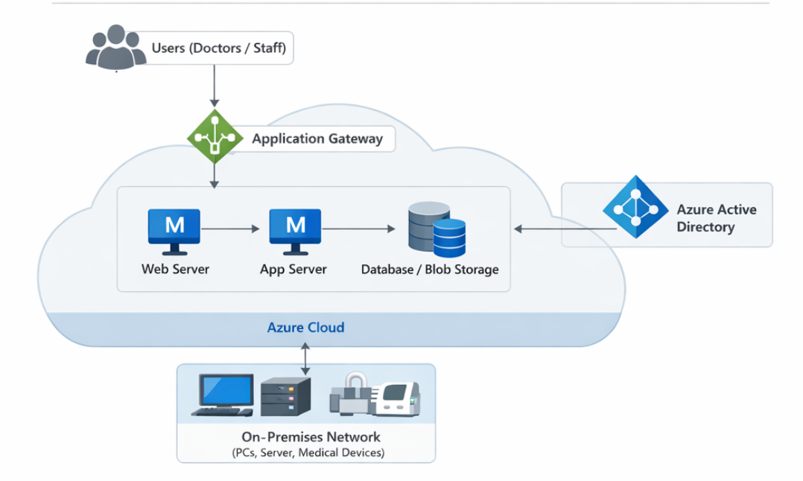
Figure 1: Current System Architecture

Threat Landscape

Ransomware, phishing, insider threats, and cloud misconfigurations are major dangers to healthcare organizations. Risk exposure is increased by lax identification constraints and accessible storage.

Key Security Findings

Missing MFA, vulnerability to public storage, permissive NSGs, a lack of segmentation, and inadequate monitoring mechanisms are some of the main problems.

Table 1: Risk Evaluation Summary

Risk Area | Likelihood | Impact | Risk Level
Identity Mismanagement | High | High | Medium
Public Data Exposure | Medium | Medium | Medium
NSG Misconfiguration | High | High | High
Lack of Segmentation | Medium | High | High
Weak Monitoring | Medium | Medium | Medium

Proposed Secure Cloud Architecture

The suggested design adheres to the Defense-in-Depth and Zero Trust tenets. MFA, RBAC, segmented VNets, private endpoints, and ongoing monitoring are all part of it.
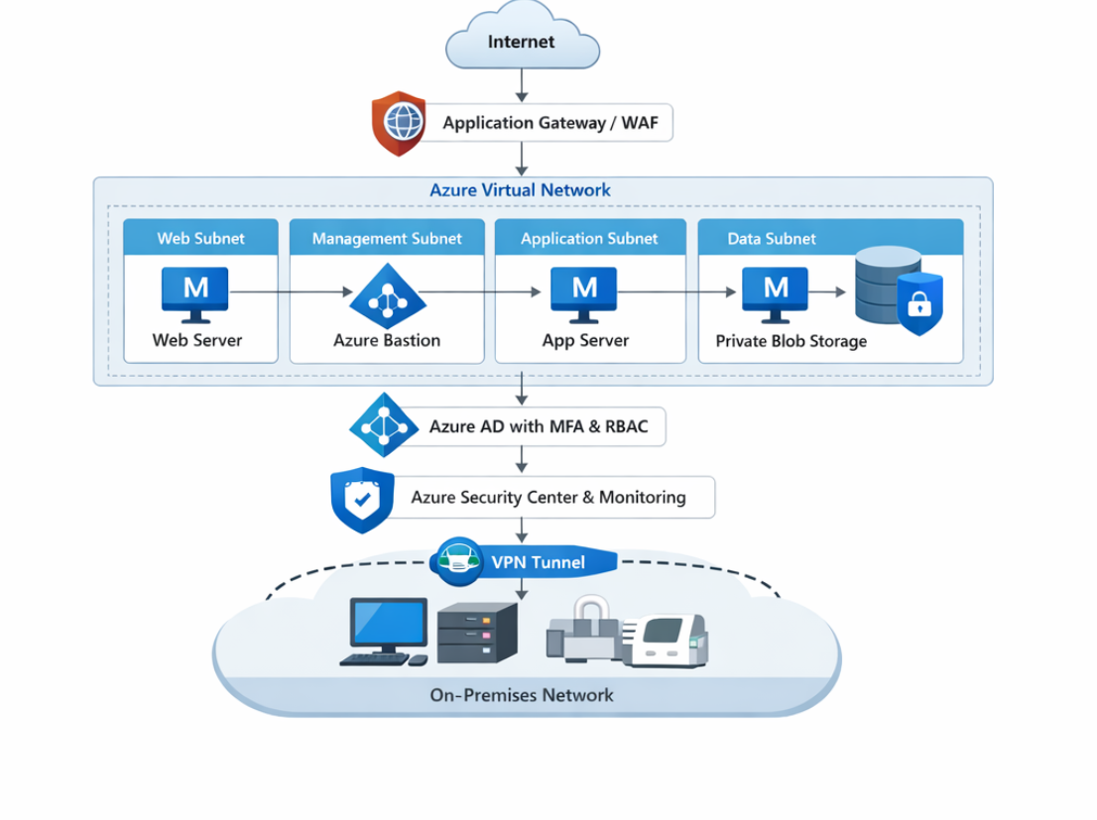
Figure 2: Proposed Secure Cloud Architecture

Table 2: Security Controls Mapping

Control Area | Recommendation | Framework Mapping
Identity Security | MFA + RBAC | NIST IA-2 / ISM
Data Protection | Encryption + Private Access | NIST SC-28 / ISM
Network Security | Restrict NSGs | NIST AC-4 / ISM
Monitoring | Azure Defender | NIST SI-4 / ISM

Benefits of Proposed Architecture

The enhanced architecture facilitates quicker threat detection, improves data security, lowers the attack surface, and increases compliance.

Compliance Considerations

Compliant with Australian ISM, NIST SP 800-53, the Privacy Act of 1988, and the My Health Records Act of 2012.

Conclusion

There are significant flaws in the current architecture. Security posture and compliance readiness will be greatly enhanced by putting the suggested model into practice.

- Evidence and Supporting Findings

Identity and Access Evidence
Accounts in Azure Active Directory were found to lack Multi-Factor Authentication (MFA). Excessive permissions were granted without Role-Based Access Control (RBAC), and inactive user accounts continued to be active. Evidence Type: Azure AD configuration evaluation.
Storage Security Evidence
Sensitive information was exposed because Azure Blob Storage containers were set up with public access enabled. There was inconsistent application of encryption policies. Storage configuration analysis is the type of evidence.
Network Security Evidence
Critical ports like RDP and SSH were open, and Network Security Groups (NSGs) permitted uncontrolled inbound traffic (0.0.0.0/0). NSG and firewall rule inspection are examples of evidence.
Network Architecture Evidence
The application, database, and user layers were not divided. The hybrid cloud connection was not properly isolated. Type of Evidence: Diagram analysis and architecture evaluation.
Monitoring and Logging Evidence
Defender and Azure Monitor were not properly set up. There was no system in place for centralized logging or alerts. Monitoring configuration review is the type of evidence.
Every piece of evidence came from an investigation of a simulated environment and was consistent with actual Azure security audit procedures.

